Curriculum Vitae page1image18749120

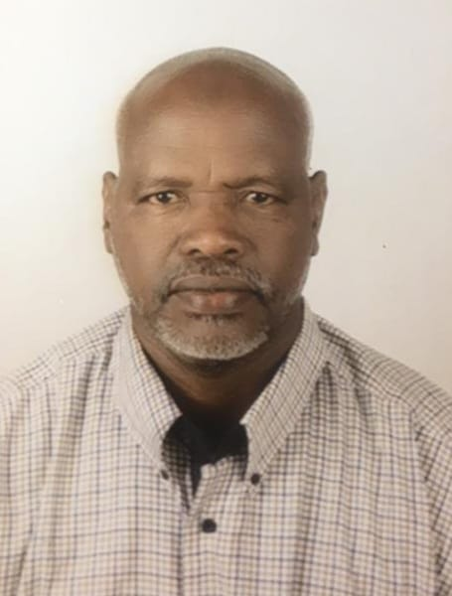***Abo-Alazim Abd-al-hafiz Abdullah Hassan*** page1image18743504

**Mobile:** +966 50 2015 024 **Email:** [aboshiba1970@gmail.com](mailto:aboshiba1970@gmail.com)  
**Date of Birth:** 9th June 1970 **Status:** Married **Nationality:** Sudani

**Expertise in Mechanical Maintenance and Operation**

Industrial mechanical and operation technician with solid hands-on experience in engine overhauling, budgeting and maintenance of generators, such as Volvo, Commins, Perkins and caterpillar Generators (Gensets) 100 KVA- 1.2MVA. I am an ambitious, diligent and professionally competent mechanical technician with overall experience of 25+ years including 10+ years in Saudi Arabia.

**Work Experience**

**Al Khalij Al Watania for Rental co. (Client Bin-Ladin), Kingdom of Saudi Arabia (KSA)**

Designation: Seiner Maintenance Mechanical Technician   
Duration: Dec 2018 to April 2024

* Overhauling Volo, Cummins, Perkins Diesel Generators.
* Supervision of maintenance schedule of Diesel Engines.
* Responsible for General Maintenance (GM), Preventive Maintenane (PM) and Corrective Maintenance (CM).
* Top-overhauling of Volvo, Cummins, Perkins.
* Inspection and Troubleshooting.
* Spare parts suggestions and ensure minimum stock availability.

Accomplishments

* Makkah Haram Mattaf Extension Project. KSA
* King’s Palace in Neom City Project. KSA
* King Abdul Aziz International Airport Jeddah. KSA
* NASMA and PARTNERS, Jeddah. KSA

**National Gulf Investment L.L.C. (Client Bin-Ladin), Kingdom of Saudi Arabia (KSA)**

Designation: Maintenance Mechanical Technician   
Duration: Jan 2013 to Nov 2018

* Overhauling Volo, Cummins, Perkins Diesel Generators.
* Supervision of maintenance schedule of Diesel Engines.
* Responsible for General Maintenance (GM), Preventive Maintenane (PM) and Corrective Maintenance (CM).
* Top-overhauling of Volvo, Cummins, Perkins.
* Inspection and Troubleshooting.
* Spare parts suggestions and ensure minimum stock availability.

Accomplishments

* Makkah Haram Mattaf Extension Project. KSA
* PREMCO Ready Mix, Bin Dubais Ready Mix. KSA
* King Abdul Aziz International Airport Jeddah Extension Project. KSA
* Arafat Day Plan and Management. KSA